Final Project Report

Face Mask Detection System



Project Supervisor
Madiha Faqir Hussain

Submitted By

F25PROJECTCC5EC

REHMAT ULLAH BC220404931

Software Projects & Research Section,
Department of Computer Sciences,
Virtual University of Pakistan


CERTIFICATE

This is to certify that REHMAT ULLAH (BC220404931), have worked on and completed their Software Project at Software & Research Projects Section, Department of Computer Sciences, Virtual University of Pakistan in partial fulfillment of the requirement for the degree of BS in Computer Sciences under my guidance and supervision.

In our opinion, it is satisfactory and up to the mark and therefore fulfills the requirements of BS in Computer Sciences.

Supervisor / Internal Examiner

Madiha Faqir Hussain
Supervisor,
Software Projects & Research Section,
Department of Computer Sciences
Virtual University of Pakistan

___________________
(Signature)

External Examiner/Subject Specialist
<<External Supervisor Name>>

___________________
(Signature)

Accepted By:

_____________
(For office use)

EXORDIUM

In the name of Allah, the Compassionate, the Merciful.

Praise be to Allah, Lord of Creation,
The Compassionate, the Merciful,
King of Judgment-day!

You alone we worship, and to You alone we pray for help,
Guide us to the straight path

The path of those who You have favored,

Not of those who have incurred Your wrath,
Nor of those who have gone astray.

DEDICATION

In the name of Allah, the Most Gracious and the Most Merciful.
I dedicate this project to Almighty Allah for granting me the strength, patience, and ability to complete this work successfully. I am deeply thankful to my parents and family for their continuous support, encouragement, and prayers throughout my academic journey.

I would also like to express my sincere gratitude to my respected supervisor, Madiha Faqir Hussain, for her valuable guidance, support, and constructive feedback during the development of this project. Finally, I appreciate my friends and classmates whose encouragement and cooperation helped me throughout this journey.

ACKNOWLEDGEMENT

All praise is due to Almighty Allah, whose blessings, guidance, and mercy enabled us to successfully complete this project Face Mask Detection System. We are grateful for the strength and patience granted to us throughout this academic journey.

I would like to express our sincere gratitude to our respected supervisor, Madiha Faqir Hussain, for her continuous guidance, valuable suggestions, and encouragement during the development of this project. Her support and professional insight greatly contributed to the successful completion of this work.

We are also thankful to our parents, family members, friends, and teachers for their motivation, support, and prayers. Their encouragement played an important role in helping us complete this project and achieve our academic goals.
PREFACE

This project report presents the design and development of the “Face Mask Detection System,”a deep learning–based application developed to detect whether a person is wearing a face mask or not. The project combines image processing, computer vision, and machine learning techniques to create an efficient and practical real-time detection system.

The purpose of this project is to explore the practical implementation of Convolutional Neural Networks (CNNs) and related technologies in solving real-world public safety challenges. The system has been developed using Python, TensorFlow/Keras, and OpenCV, with support for image-based and real-time webcam detection.

This report documents the complete development process, including data collection and preprocessing, model training, system implementation, testing, and performance evaluation. The project also reflects the knowledge and skills gained during the BS Computer Science program and demonstrates the practical application of modern AI technologies in everyday scenarios.

Table of Contents

CHAPTER NO. 1
gathering & Analyzing info 9

1.1. Introduction 9
1.2. purpose 9
1.3. scope 9
1.4. definitions, acronyms and abbreviations 10
1.5. Project requirements 11
1.5.1 Functional Requirements 11
1.5.2 Non-Functional Requirements 12
1.6. use cases and usage scenarios 14
1.6.1 Use Case Diagrams 14
1.6.2 Usage Scenarios 15
1.7 Development Methodology 22
1.7.1 Chosen Methodology 22
1.7.2 Reasons for Chosen Methodology 23
1.7.3 Work Plan (Gantt Chart) 23
1.7.4 Project Schedule (Submission Calendar) 23

CHAPTER NO. 2
designing the project 28
2.1 Introduction 25
2.2 Purpose 25
2.3 Scope 25
2.4 definitions, acronyms and abbreviations 26
2.5 Architectural Representation (Architecture Diagram) 27
2.6 Dynamic Model: Sequence Diagrams 27
2.7 Object Model/Logical Model: Class Diagram 30
2.8 Database Model (Database Diagram) 31
2.9 Graphical User Interfaces 31

Chapter no.3
DEvelopment 13
3.1. Development plan (Architecture Diagram 36

CHAPTER 1
Gathering & Analyzing Info

- Introduction

This project aims to develop an automated face mask detection system using deep learning techniques. The system will identify whether a person in an image is wearing a mask or not wearing a mask. A Convolutional Neural Network (CNN) model will be trained on a dataset containing face images with and without masks. The model will be integrated with a real-time detection interface to monitor live camera feeds or uploaded images. This technology can be applied in public safety monitoring, hospital check-ins, and smart surveillance systems

- Purpose

The purpose of the Face Mask Detection System is to develop an automated and intelligent solution that can identify whether a person is wearing a face mask or not using computer vision and deep learning techniques. This system aims to support public safety measures by enabling fast and accurate monitoring in real-time environments such as hospitals, airports, schools, and other public places.
Another key objective of this project is to apply and demonstrate the practical use of Convolutional Neural Networks (CNNs) in image classification tasks. It helps in understanding how machine learning models can be trained, optimized, and deployed for real-world applications. The system is also designed to reduce the need for manual monitoring and improve efficiency in enforcing safety protocols.

- Scope

The scope of this project is to develop an automated Face Mask Detection System using deep learning and computer vision techniques. The system will detect whether a person is wearing a face mask or not from images and real-time video streams using a trained Convolutional Neural Network (CNN) model.
The project includes data collection, preprocessing, model training, face detection, and system implementation using technologies such as Python, OpenCV, and TensorFlow/Keras. It supports both image upload detection and real-time webcam-based monitoring through a user-friendly interface. The system will also store detection results, timestamps, and prediction records in a database for analysis and monitoring purposes.
Additionally, the project involves evaluating and optimizing the model under different lighting and environmental conditions to ensure accuracy, speed, and reliable real-world performance in areas such as hospitals, educational institutions, and public safety environments.

- definitions, acronyms and abbreviations

Acronym / Term | Definition
AI | Artificial Intelligence. It enables machines to perform tasks that normally require human intelligence.
Deep Learning | A subset of artificial intelligence that enables computers to learn patterns and make predictions using neural networks.
CNN | Convolutional Neural Network. A deep learning algorithm mainly used for image classification and detection tasks.
OpenCV | Open Source Computer Vision Library. It is used for image processing and real-time face detection.
TensorFlow | An open-source deep learning framework developed by Google. It is used for training and deploying machine learning models.
Keras | A high-level API used for building deep learning models. It works on top of TensorFlow for easier model development.
MobileNetV2 | A lightweight deep learning model used for image classification and real-time detection tasks.
Python | A programming language used for developing the face mask detection system and training the model.
HTML | HyperText Markup Language. It is used to create the structure of web pages for the system interface.
CSS | Cascading Style Sheets. It is used for designing and styling the web interface of the system.
SQL | Structured Query Language. It is used for storing and managing project-related data in databases.
Dataset | A collection of labeled images used for training and testing the model.
Real-Time Detection | The ability of the system to analyze live webcam or camera feeds instantly.

- Project requirements

1.5.1 Functional Requirements

FR1 — Data Collection & Preprocessing

1.1 Collect or create a dataset containing face images with and without masks.
1.2 Apply face detection using OpenCV or MediaPipe.
1.3 Resize and normalize images for model compatibility.
1.4 Perform data augmentation (e.g., rotation, flipping, brightness adjustment) to
improve generalization.

FR2 —Model Development

2.1 Implement a Convolutional Neural Network (CNN) or fine-tune a pretrained
model (such as MobileNet or VGG16).
2.2 Train the model to classify images into two categories: Mask and No Mask.
2.3 Use dropout, batch normalization, and hyperparameter tuning to optimize
performance.
2.4 Target validation accuracy above 95%.

FR3 —User Interface Development

3.1 Desktop Application (Tkinter/PyQt):
Allow users to upload photos for detection.
Display prediction results and confidence scores.
3.2 Web Application (Flask/Django):
Provide a web-based interface for image uploads or live camera feed detection.

FR4 —Real-Time Detection

4.1 Use OpenCV to capture live video from a webcam or CCTV feed.
4.2 Detect and classify faces as Mask or No Mask in real-time.
4.3 Display bounding boxes and labels with confidence levels.

FR5 —Database Integration

5.1 Store detection results including timestamps, image paths, and predictions using
SQLite or MySQL.
5.2 Allow administrators to view and analyze detection statistics.

FR6 —Performance Evaluation & Optimization

6.1 Evaluate system performance using metrics such as accuracy, precision, recall,
and F1-score.
6.2 Test under various lighting and camera conditions.
6.3 Optimize the model for faster real-time performance while maintaining high
accuracy.

1.5.2 Non-Functional Requirements

NFR1 — Performance

The system should classify a face in less than 1-3 seconds.
The system must detect and classify faces (Mask / No Mask) in real-time with at least 15 FPS on a standard webcam.
The accuracy of predictions should be ≥ 95%.

NFR2 — Reliability

The system should maintain at least 95% uptime during normal use.
The system must produce consistent results under varying conditions.
The model should not crash during real-time video processing.

NFR3 — Accuracy & Quality Requirements

The trained model should achieve:
Training accuracy ≥ 95%
Validation accuracy ≥ 95%

NFR4 — Usability

The user interface (Desktop or Web) must be simple, intuitive, and user-friendly for non-technical users.
Buttons, labels, and messages must be clearly readable and properly placed.
Users should be able to upload an image or start a webcam session in 1–2 clicks.
Proper error messages must be displayed for:
Invalid image formats
Camera access failure
No face detected

NFR5 — Scalability

The system should be able to handle:
Multiple face detections in a single frame.
Growing database entries without performance degradation.

NFR6 — Security

• User-uploaded images must be processed securely.
• Database logs must be protected against unauthorized access.

NFR7 — Maintainability

The code should follow clean coding practices
Modules should be separated as:
Data preprocessing
Real-time detection
User interface
Database operations
Comments and documentation should be provided for all major functions.

NFR8 — Portability

The application must run on:
Windows 10 / 11
The web version should run in all major browsers (Chrome, Firefox, Edge).

NFR9 — Compatibility Requirements

The system should be compatible with:
Python 3.8+
OpenCV, TensorFlow/Keras/PyTorch
SQLite/MySQL
Must support standard webcam devices without requiring special drivers.

NFR10 — Ethical & Privacy Requirements

The system must not use collected images for any purpose other than mask detection.
The system must avoid race, age, or gender bias during detection.

- use cases and usage scenarios

1.6.1 Use Case Diagrams
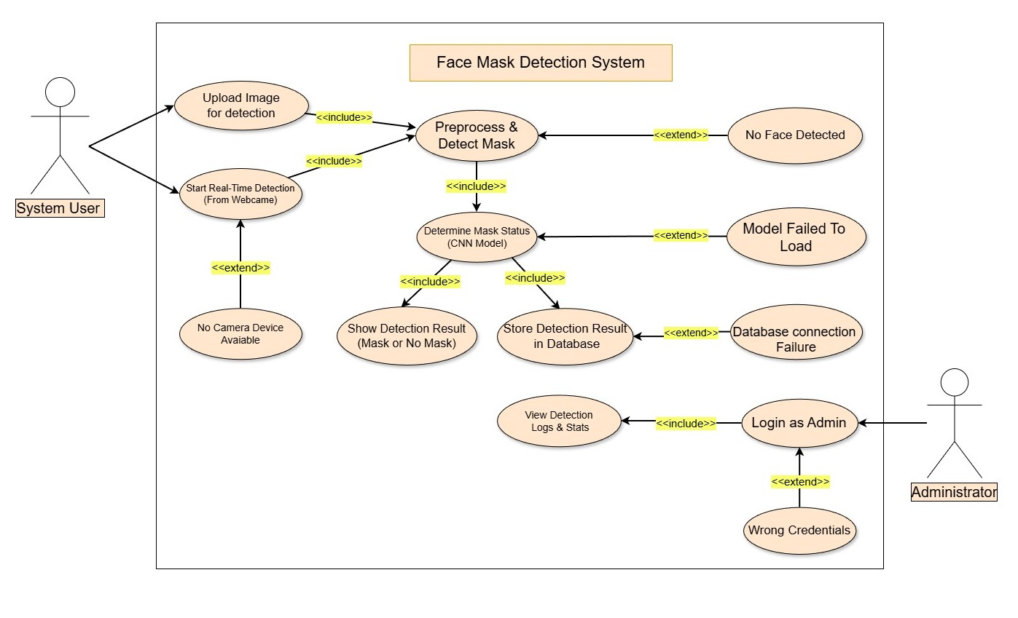

1.6.2 Usage Scenarios

Item | Description
Use Case Title | Upload Image for Detection
Use Case ID | UC-01
Actor | System User
Description | The user uploads a static image file to the system to check if the person in the image is wearing a face mask or not
Pre-Conditions | System running; image available.
Post-Conditions | Image forwarded for processing.
Main Actions | 1. User selects "Upload Image" option  2. System displays file browser dialog  3. User selects image file (JPG/PNG)  4. System validates file format  5. System processes image
Alternative Paths | - User cancels image upload.  - User uploads different image after failure.  - User chooses wrong file
Exceptions | Invalid format.  Corrupted file.  File Size exceed than 5 MB
Author | Rehmat Ullah — BC220404931

Item | Description
Use Case Title | Start Real-Time Detection (From Webcam)
Use Case ID | UC-02
Actor | System User
Description | The user activates the webcam for real time detection to detect face masks in real-time.
Pre-Conditions | - A camera device is connected and drivers are installed  - User has granted camera permissions.
Post-Conditions | Frames sent for processing to detect mask.
Main Actions
  - User clicks real-time detection.
  - System checks for camera.
  - Webcam initializes.
  - Live frames captured.
Alternative Paths | User stops detection manually.  Camera disconnects from the system
Exceptions | No camera Device Available → UC-13.
Author | Rehmat Ullah — BC220404931

Item | Description
Use Case Title | Preprocess & Detect Mask
Use Case ID | UC-03
Actor | Internal System
Description | Preprocesses input and performs face detection.
Pre-Conditions | Valid input available.
Post-Conditions | Preprocessed image sent to Determine Mask Status (CNN Model)
Main Actions | Detect face  Resize/normalize image
Alternative Paths | None
Exceptions | No face Detected → UC-09.
Author | Rehmat Ullah — BC220404931

Item | Description
Use Case Title | Determine Mask Status (CNN Model)
Use Case ID | UC-04
Actor | Internal System
Description | The core processing unit that analyzes the face data to classify the face status as Mask/No Mask using CNN.
Pre-Conditions | Preprocessed image must exist.  CNN model must be loaded.
Post-Conditions | Output available for display & storage.  A classification (Mask / No Mask) is returned
Main Actions | - Load CNN model.  - Run prediction.  - Generate confidence score.  - Send output to UI & DB module.
Alternative Paths | No Face
Exceptions | Model Failed to Load→ UC-10.
Author | Rehmat Ullah — BC220404931

Item | Description
Use Case Title | Show Detection Result
Use Case ID | UC-05
Actor | Internal System
Description | System displays the final mask detection status to the user.
Pre-Conditions | Valid classification results available
Post-Conditions | User views final detection output.
Main Actions | - Receive prediction result.  - Display mask/no-mask label.  - Show confidence score and bounding boxes.
Alternative Paths | None
Exceptions | Missing result.
Author | Rehmat Ullah — BC220404931

Item | Description
Use Case Title | Store Detection Result in Database
Use Case ID | UC-06
Actor | Internal System
Description | Saves mask detection result into database.
Pre-Conditions | Result must be generated.
Post-Conditions | Entry stored successfully.
Main Actions | - Prepare data (status, timestamp etc).  - Connect to DB.  - Insert detection record.
Alternative Paths | System retries if DB is busy.
Exceptions | Database connection Failure → UC-11.
Author | Rehmat Ullah — BC220404931

Item | Description
Use Case Title | View Detection Logs & Stats
Use Case ID | UC-07
Actor | Administrator
Description | Allows authorized administrators to view historical detection data
Pre-Conditions | Admin logged in.
Post-Conditions | Logs displayed.
Main Actions | - Admin opens logs.  - System retrieves entries.  - Display logs & stats.
Alternative Paths | None
Exceptions | No logs available in database.  DB read error
Author | Rehmat Ullah — BC220404931

Item | Description
Use Case Title | Login as Admin
Use Case ID | UC-08
Actor | Administrator
Description | Admin logs into system for privileged access.
Pre-Conditions | Credentials must exist.
Post-Conditions | Admin panel displayed.
Main Actions | 1. Enter username & password.  2. System validates credentials.  3. Admin redirected to dashboard.
Alternative Paths | Retry login
Exceptions | Wrong credentials → UC-12.
Author | Rehmat Ullah — BC220404931

Item | Description
Use Case Title | No Face Detected
Use Case ID | UC-09
Actor | Internal System
Description | Triggered when the system fails to detect any face in the input.
Pre-Conditions | Face detection executed.
Post-Conditions | User informed.
Main Actions
  - System runs face detection.
  - No face detected.
  - Display error message to user.
Alternative Paths | User retries with new image
Exceptions | None
Author | Rehmat Ullah — BC220404931

Item | Description
Use Case Title | Model Failed to Load
Use Case ID | UC-10
Actor | Internal System
Description | CNN model could not be loaded.
Pre-Conditions | CNN model required.  Classification request initiated.
Post-Conditions | Detection halted.
Main Actions | - System attempts to load model.  - Loading fails.  - System shows failure message.
Alternative Paths | None
Exceptions | None
Author | Rehmat Ullah — BC220404931

Item | Description
Use Case Title | Database Connection Failure
Use Case ID | UC-11
Actor | Internal System
Description | System cannot connect to database.
Pre-Conditions | Store operation triggered.
Post-Conditions | Record not saved.
Main Actions
  - System attempts DB connection.
  - Connection fails.
  - System shows DB failure message.
Alternative Paths | None
Exceptions | None
Author | Rehmat Ullah — BC220404931

Item | Description
Use Case Title | Wrong Credentials
Use Case ID | UC-12
Actor | Administrator
Description
  Triggered when the admin enters invalid login information.
Pre-Conditions | Login attempt made.
Post-Conditions | Access denied.
Main Actions | - Admin submits credentials.  - System detects mismatch.  - Error message shown.
Alternative Paths | Admin retries login
Exceptions | None
Author | Rehmat Ullah — BC220404931

Item | Description
Use Case Title | No Camera Device Available
Use Case ID | UC-13
Actor | Internal System
Description | Webcam missing when real-time detection starts.
Pre-Conditions | User requested real-time detection.
Post-Conditions | Process stops.
Main Actions
  - System searches for camera.
  - No device detected or camera is busy.
  - System shows error to user.
Alternative Paths | User connects camera and retries.  User upload image using image upload option.  System scans for secondary camera.
Exceptions | None
Author | Rehmat Ullah — BC220404931

1.7 Development Methodology

1.7.1 Chosen Methodology
A software engineering methodology is a systematic approach that defines the procedures and stages used in software development. It offers organized guidelines for analyzing requirements, creating designs, coding, testing, and releasing software systems. Using a well-defined methodology helps development teams maintain uniformity, improve productivity, and deliver reliable, high-quality software solutions.

Vu Process Model:
This model is created by combining both the Waterfall and Spiral models, which makes it a good fit for my system because it includes structured steps as well as areas that need continuous improvement, such as machine learning.
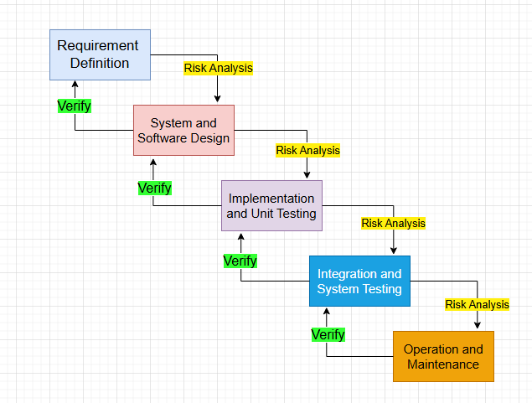

1.7.2 Reasons for Chosen Methodology
I selected the VU Process Model for our project because it divides the work into clear phases that are completed one after another and submitted to the supervisor for review. If any mistakes or issues are found, they can be corrected and improved before moving forward. The model combines the flexibility of the spiral approach with the step-by-step structure of the waterfall model. After one phase is properly completed and approved, the team proceeds to the next phase. This organized process helps reduce errors and ensures better project quality.

1.7.3 Work Plan (Gantt Chart)
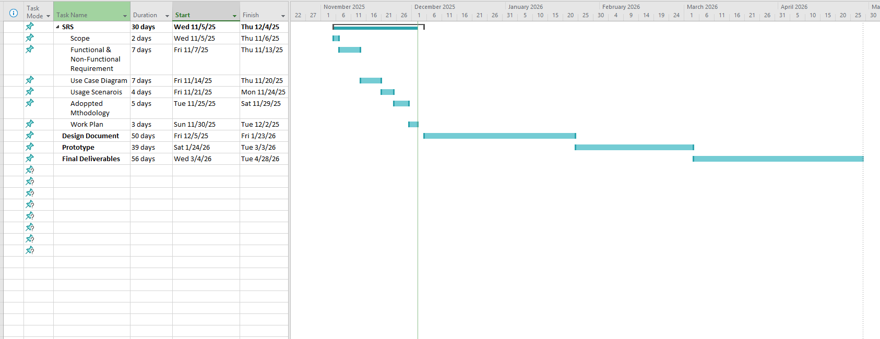

1.7.4 Project Schedule (Submission Calendar)

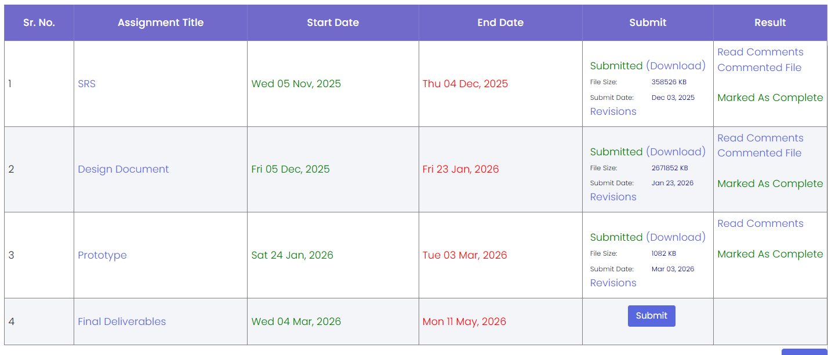

CHAPTER 2
Designing the Project

2.1 Introduction

This project aims to develop an automated face mask detection system using deep learning techniques. The system will identify whether a person in an image is wearing a mask or not wearing a mask. A Convolutional Neural Network (CNN) model will be trained on a dataset containing face images with and without masks. The model will be integrated with a real-time detection interface to monitor live camera feeds or uploaded images. This technology can be applied in public safety monitoring, hospital check-ins, and smart surveillance systems

2.2 Purpose

The purpose of the Face Mask Detection System is to develop an automated and intelligent solution that can identify whether a person is wearing a face mask or not using computer vision and deep learning techniques. This system aims to support public safety measures by enabling fast and accurate monitoring in real-time environments such as hospitals, airports, schools, and other public places.
Another key objective of this project is to apply and demonstrate the practical use of Convolutional Neural Networks (CNNs) in image classification tasks. It helps in understanding how machine learning models can be trained, optimized, and deployed for real-world applications. The system is also designed to reduce the need for manual monitoring and improve efficiency in enforcing safety protocols.

2.3 Scope

The scope of this project is to develop an automated Face Mask Detection System using deep learning and computer vision techniques. The system will detect whether a person is wearing a face mask or not from images and real-time video streams using a trained Convolutional Neural Network (CNN) model.
The project includes data collection, preprocessing, model training, face detection, and system implementation using technologies such as Python, OpenCV, and TensorFlow/Keras. It supports both image upload detection and real-time webcam-based monitoring through a user-friendly interface. The system will also store detection results, timestamps, and prediction records in a database for analysis and monitoring purposes.
Additionally, the project involves evaluating and optimizing the model under different lighting and environmental conditions to ensure accuracy, speed, and reliable real-world performance in areas such as hospitals, educational institutions, and public safety environments.

2.4 definitions, acronyms and abbreviations

Acronym / Term | Definition
AI | Artificial Intelligence. It enables machines to perform tasks that normally require human intelligence.
Deep Learning | A subset of artificial intelligence that enables computers to learn patterns and make predictions using neural networks.
CNN | Convolutional Neural Network. A deep learning algorithm mainly used for image classification and detection tasks.
OpenCV | Open Source Computer Vision Library. It is used for image processing and real-time face detection.
TensorFlow | An open-source deep learning framework developed by Google. It is used for training and deploying machine learning models.
Keras | A high-level API used for building deep learning models. It works on top of TensorFlow for easier model development.
MobileNetV3 | A lightweight deep learning model used for image classification and real-time detection tasks.
Python | A programming language used for developing the face mask detection system and training the model.
HTML | HyperText Markup Language. It is used to create the structure of web pages for the system interface.
CSS | Cascading Style Sheets. It is used for designing and styling the web interface of the system.
SQL | Structured Query Language. It is used for storing and managing project-related data in databases.
Dataset | A collection of labeled images used for training and testing the model.
Real-Time Detection | The ability of the system to analyze live webcam or camera feeds instantly.

2.5 Architectural Representation (Architecture Diagram)

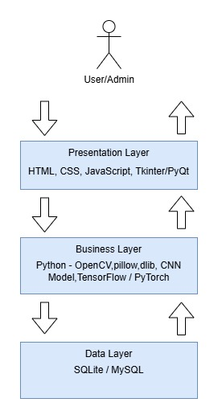

2.6 Dynamic Model: Sequence Diagrams

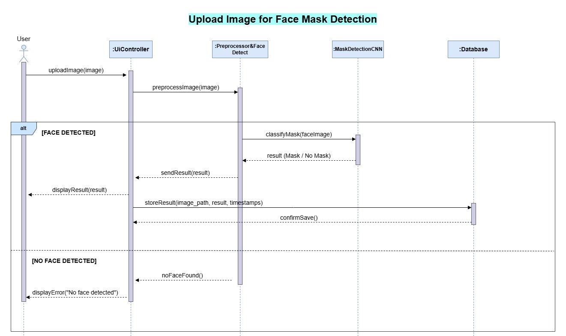
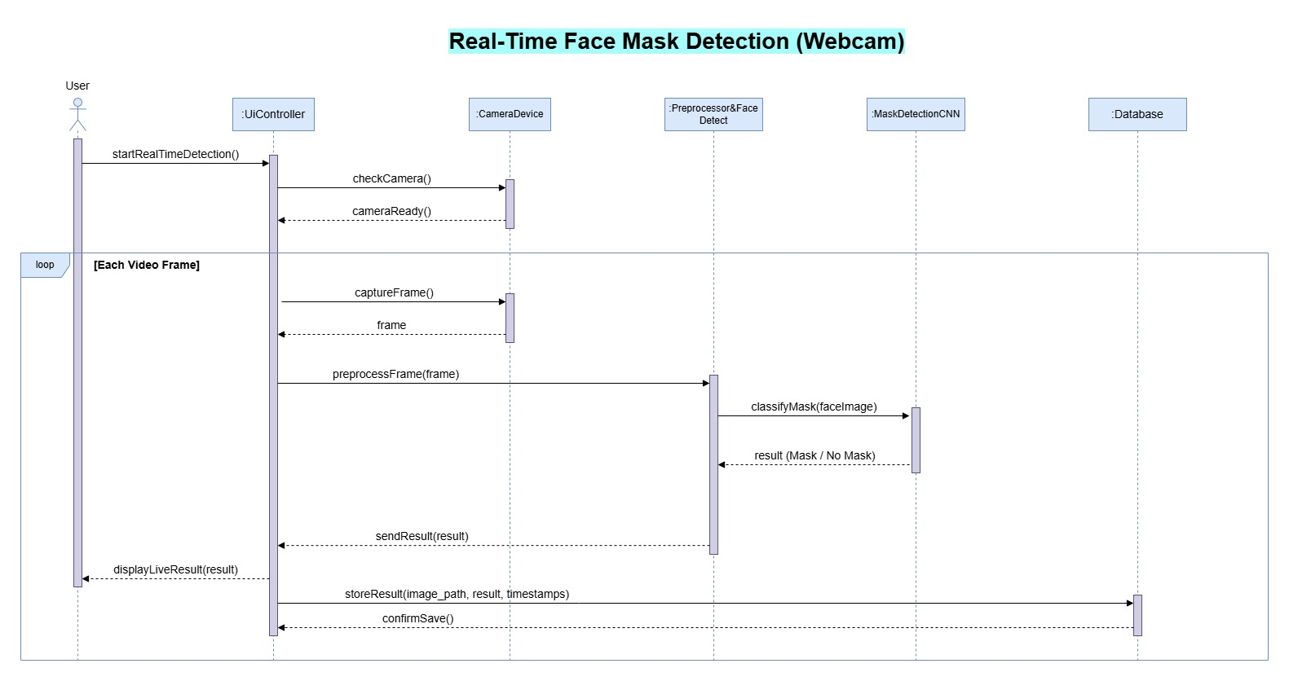

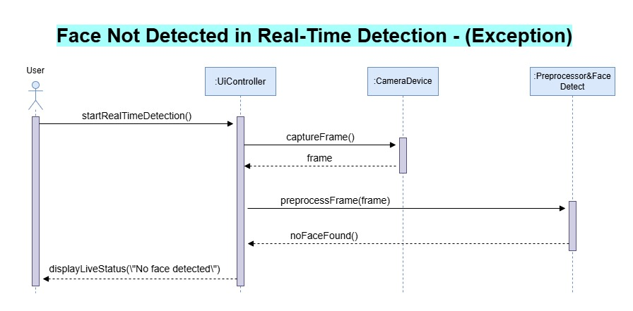

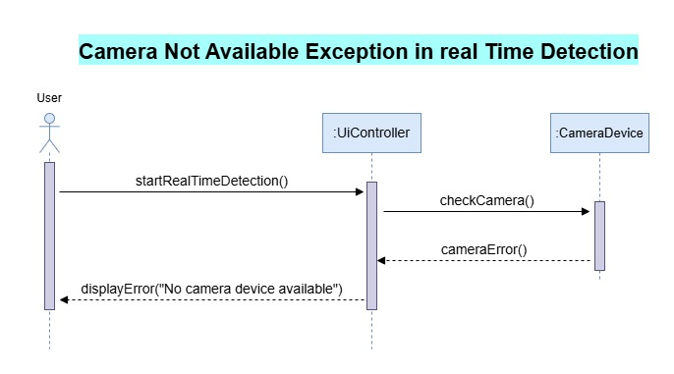

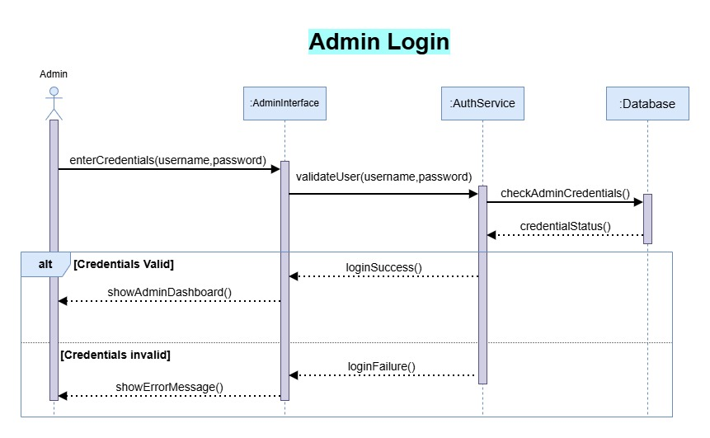

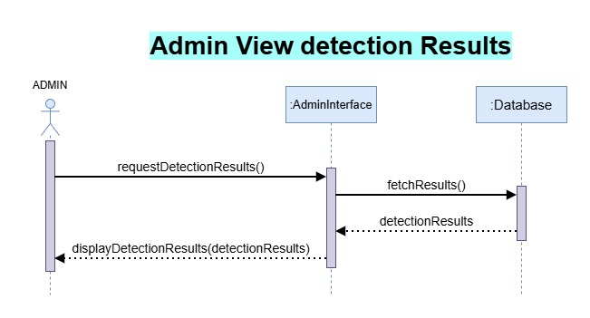

2.7 Object Model/Logical Model: Class Diagram

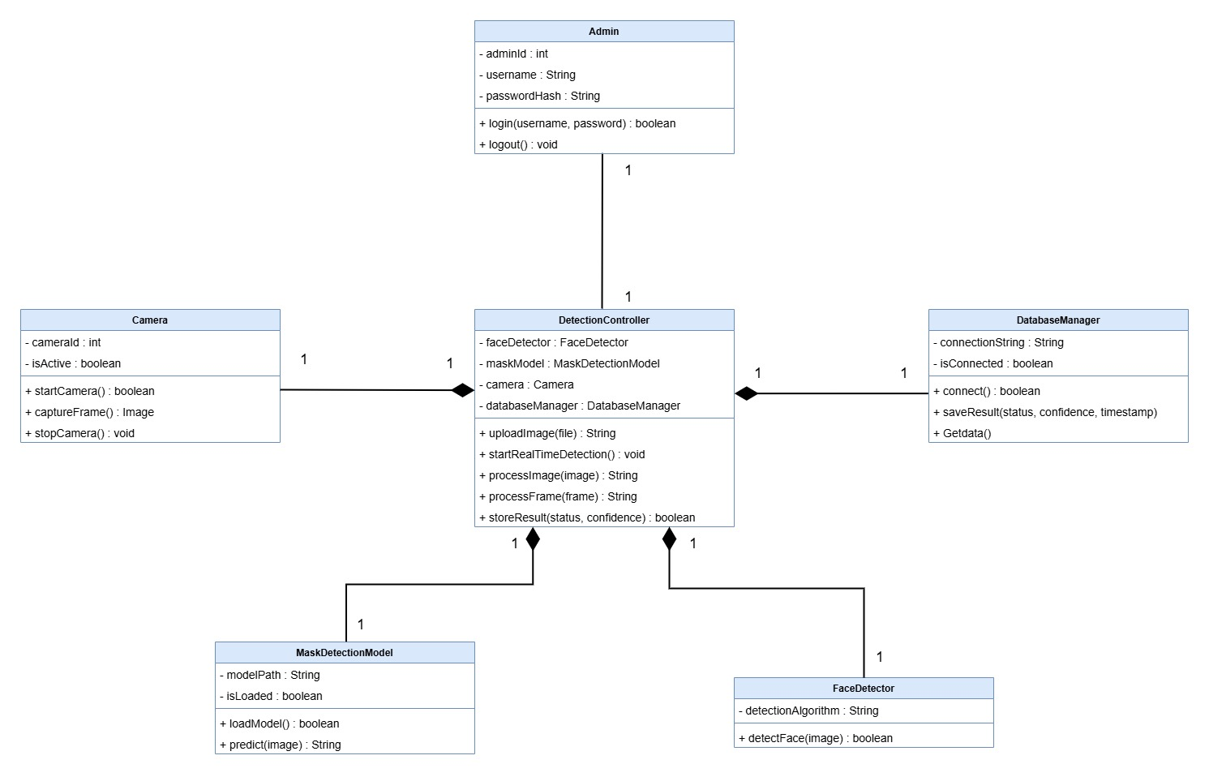

2.8 Database Model (Database Diagram)

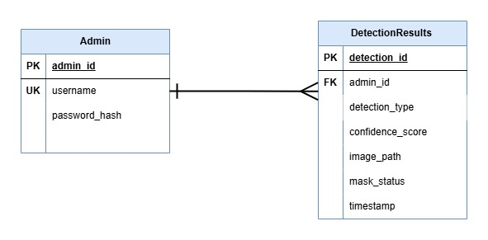

2.9 Graphical User Interfaces

WebApp Main Page

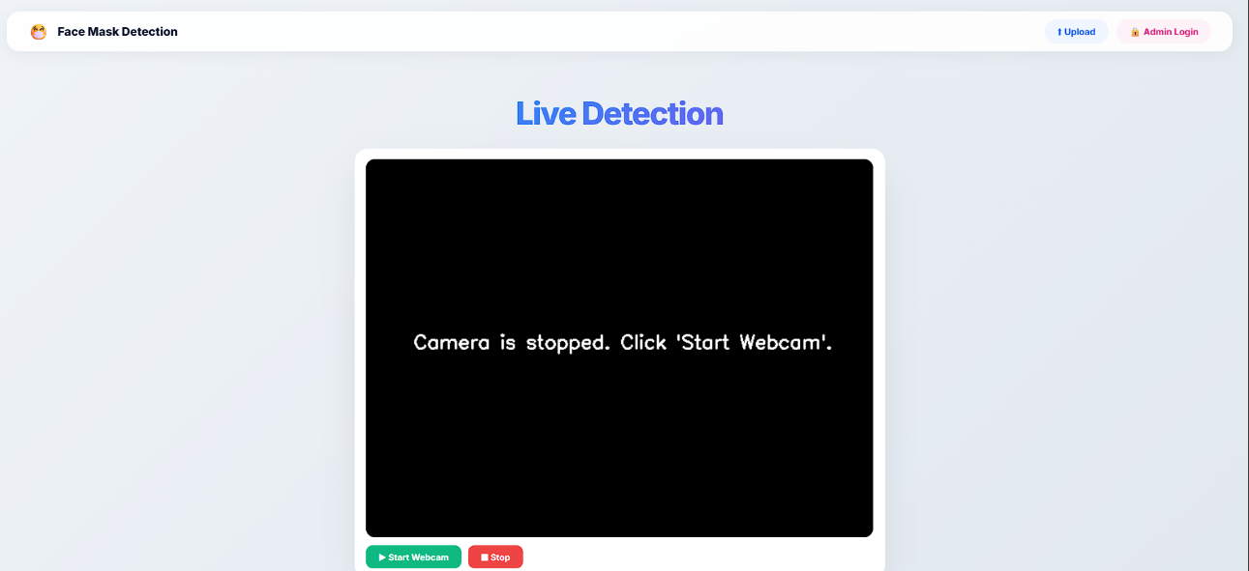

Upload Image for Detection

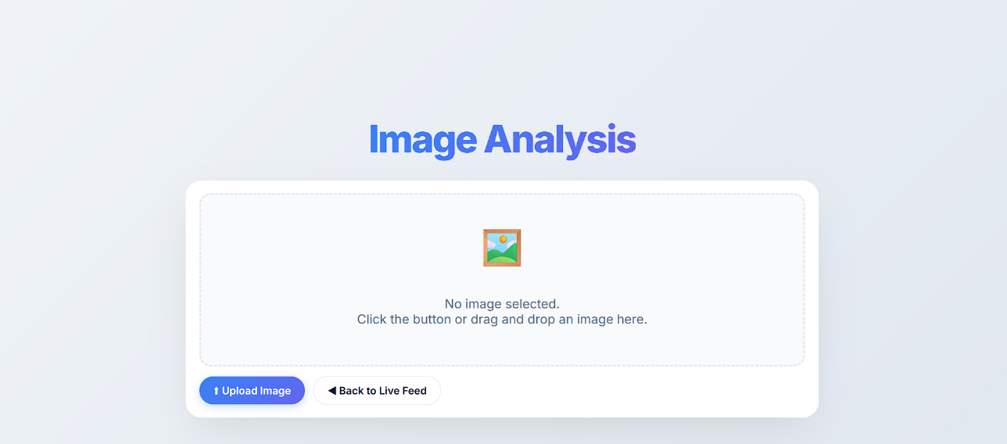

Uploaded Image Results

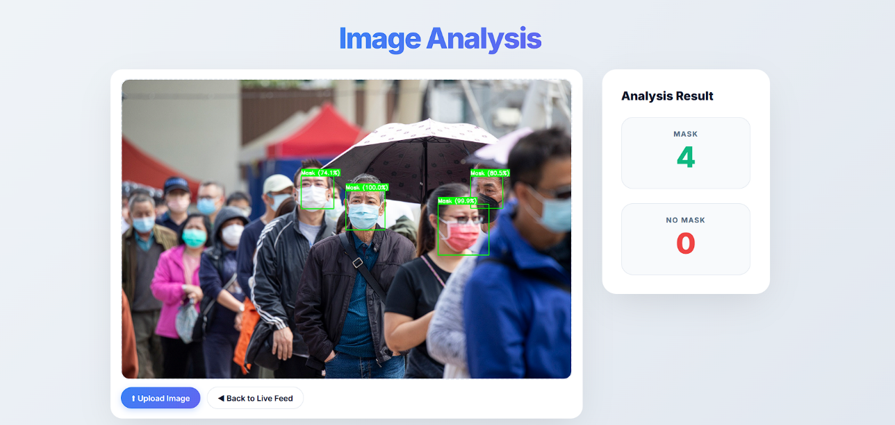

Admin Login



Admin Dashboard

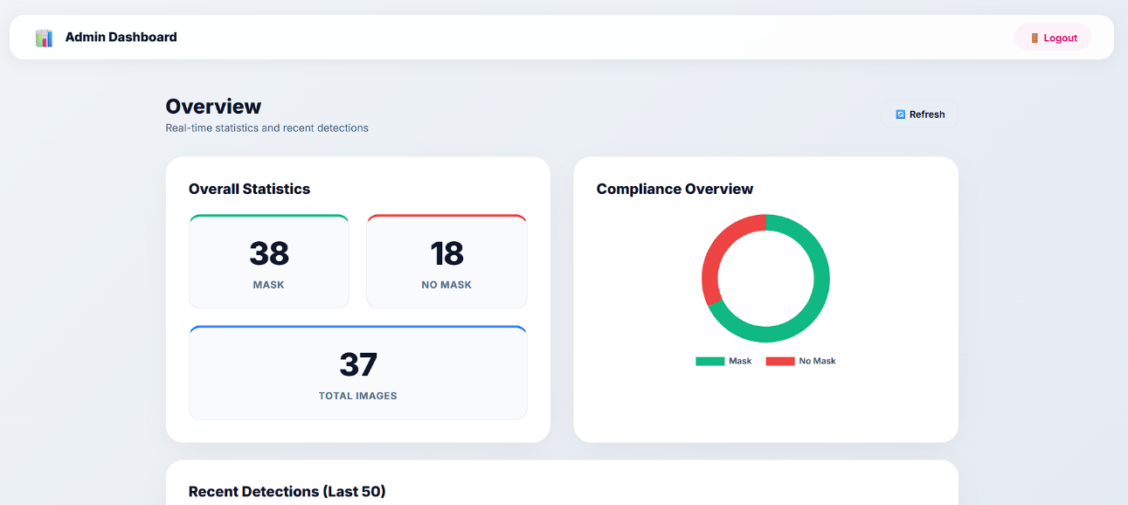

Desktop App Mian Interface

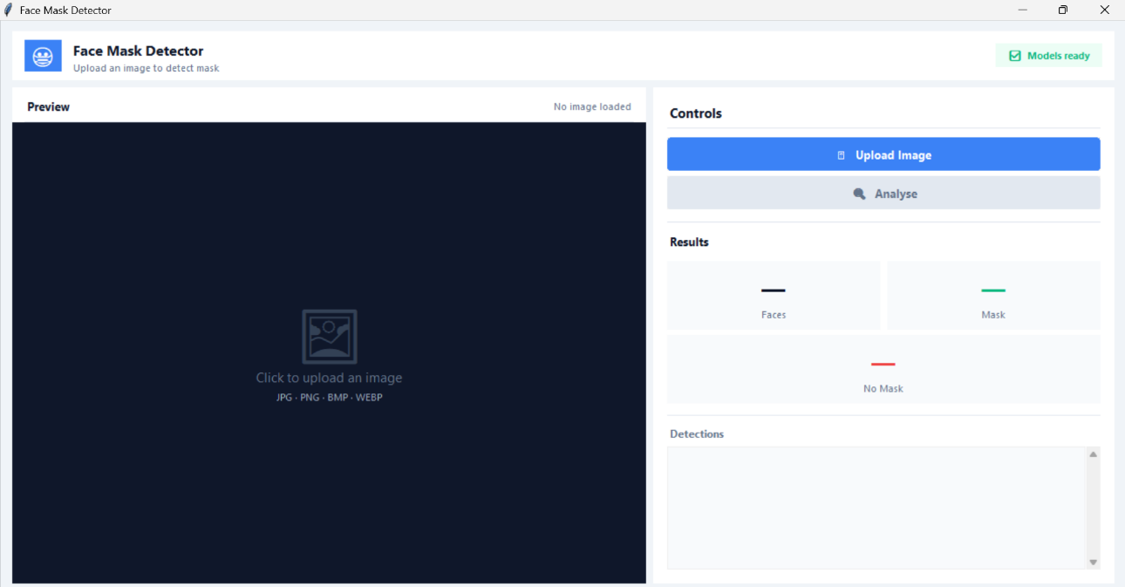

Desktop App Detection Results

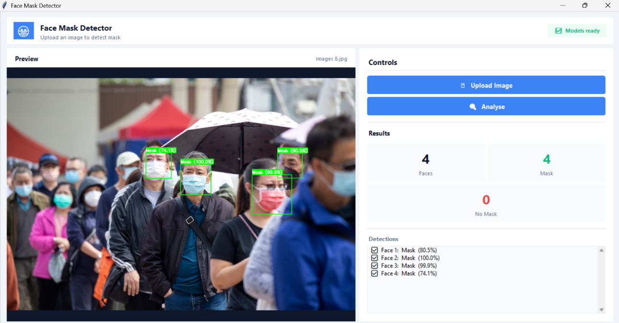

CHAPTER 3
Development

Development plan (Architecture Diagram

REFERENCES

• TensorFlow
TensorFlow Developers. TensorFlow Machine Learning Framework.
• OpenCV
OpenCV Team. Open Source Computer Vision Library.
• Keras Documentation
Keras Developers. Deep Learning API for Python.
• Flask Official Documentation
Pallets Projects. Flask Web Framework.
• MediaPipe Official Documentation
Google Developers. MediaPipe Machine Learning Solutions.
• Dataset
Dataset for training the model
• Tkinter
Desktop App with Python Tkinter.
- Python
Python programming language for the entire project
- HTML and CSS
For the structure and styling of the web app
- SQL
For storing and fetching records in/from the database
- NumPy
A Python library used for numerical computations

APPENDIX

Class Diagram
A UML diagram showing the object-oriented structure of the Face Mask Detection System, including its main modules and their relationships. It defines how different components interact to process images and produce detection results.

Sequence Diagram
A UML diagram that shows the step-by-step flow of interactions between system components over time. It explains how input data moves through detection and classification until the final output is generated.

Database Diagram
A visual representation of the database structure used in the system, showing tables and their relationships. It organizes how detection data and system records are stored and managed.

Entity Relationship Diagram (ERD)
A diagram that shows relationships between system entities such as user, input image, and prediction result. It helps in designing how data is logically connected and stored in the system.

Python
A high-level programming language used to develop the Face Mask Detection System. It is used for implementing the deep learning model, handling image processing, and integrating all system components.

TensorFlow
An open-source deep learning framework used for building, training, and deploying the convolutional neural network (CNN) model for mask detection.

Keras
A user-friendly deep learning API that runs on top of TensorFlow. It is used to design and train neural network models in a simplified way.

OpenCV
A computer vision library used for image processing tasks such as face detection, frame capturing, and real-time video stream handling.

MobileNetV3
A lightweight pre-trained deep learning model used for efficient feature extraction and real-time classification of face mask and no mask images.

HTML
A markup language used to create the structure of the web-based interface for user interaction with the system.

CSS
A styling language used to design and enhance the visual appearance of the web interface, making it user-friendly.

SQL
A structured query language used for managing and storing system data such as detection logs, user records, and results in a database (if implemented).

NumPy
A Python library used for numerical computations and efficient handling of image arrays during preprocessing and model input preparation.

